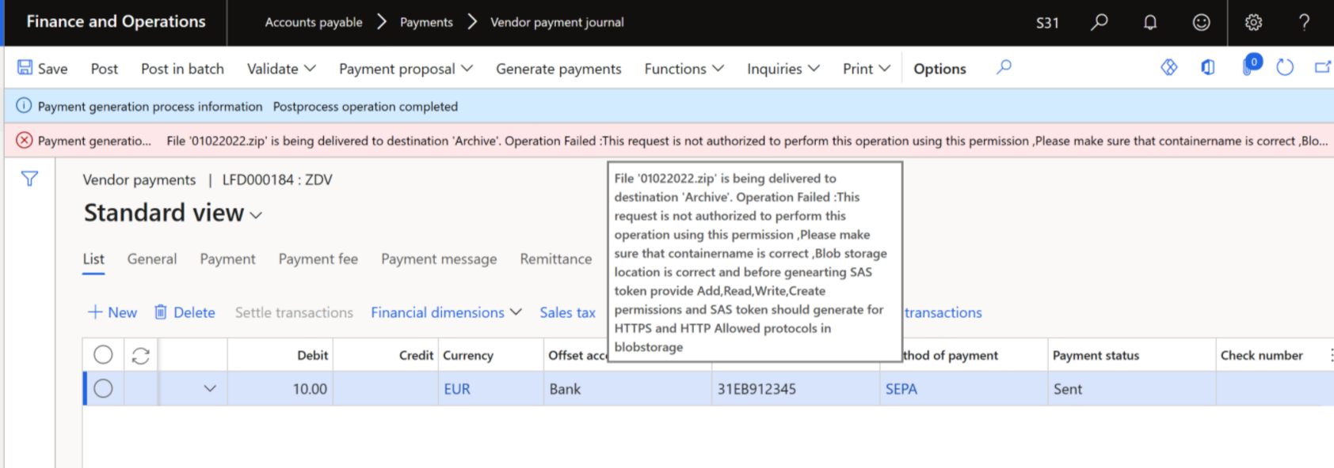

If we got this error message when we are sending a file from F&O to Blog storage, Make sure that

1) Blob storage location name is correct.

2) Container name is correct, In our case we are using is etlbanking Container.

3) Generate the SAS token with Read, Write, Add, Create permissions and Allowed protocols should be HTTPS and HTTP.

Then generate the SAS token and copy the token

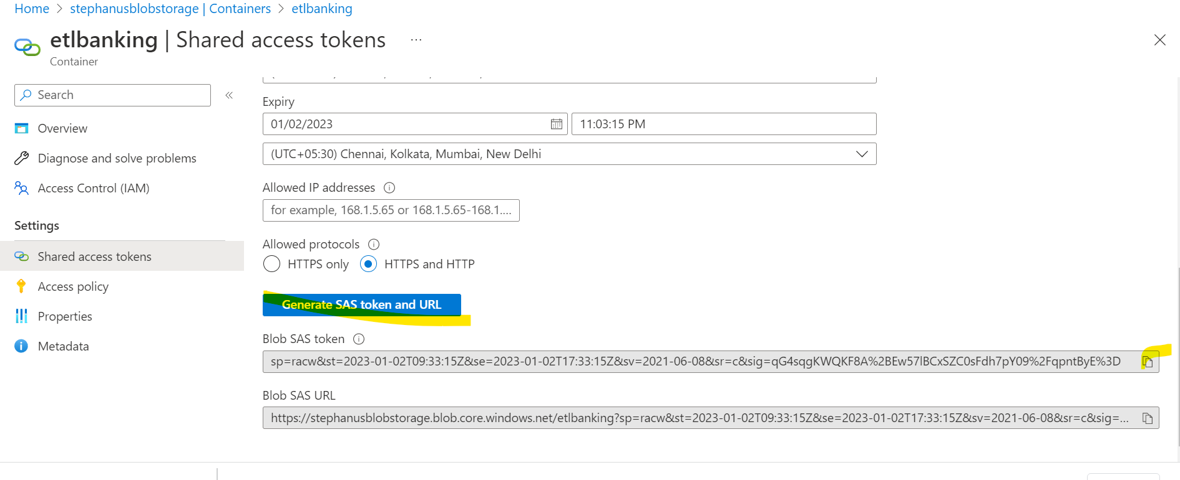

Go to Organisation administration -> Document management -> Document Types -> Blob storage tab

Re enter all the details

1. Container name (our case ) - etlbanking.
2. Blob storage location - StephanusBlobStorage.
3. SAS Token - \*\*\*\*\*\*\*\*\*\*\*\*\*.

Save and Do the process from Initial.